**2016 8 SCIENCE INVESTIGATION**

The Pendulum

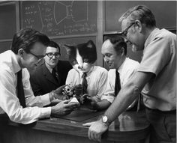

Name: _______________________ Teacher: ____________________

Form: _______________________ Due date: ___________________

**Plagiarism**

You must write in your own words, not copy sentences word for word from another student or another source.

Plagiarising = instant zero on assignment and you will have to re-do it.

**Assessment policy**

Give me a sick note/legitimate reason from parent BEFORE due date = new negotiated due date.

One day late = -20% taken off mark

Two days late = -40% taken off mark

Three days late = mark of zero given

After three days, students are required to attend a detention and are still required to submit the assignment.

**If you are not at school the day this assignment is due, please email it to your teacher by the deadline they have given you.**

**Teacher email: @aranmore.wa.edu.au**

**Background:** A pendulum is a mass (called a bob) attached to a rod, chain or rope that swings back and forth repeatedly. One complete swing, back and forth is called a period. The frequency is the number of complete swings it makes every second.

**Aim:** To investigate the effect that either the length of the string or the mass of the bob on a pendulum has on the time it takes for 5 complete swings.

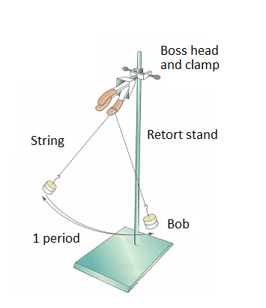

Tick the variable that your group has chosen to change.

The length of the string 🞏

The mass of the bob 🞏

**Suggestions:** measure how many seconds it takes for 5 complete swings and do this a number of times then take the average result. For example, have three trials in your results table then graph the average times.

Clamp the base of your retort stand to the bench top to keep it stable.

**Hypothesis:** (one sentence prediction of what you think will happen, do not use personal language)  **(2 marks)**

_________________________________________________________________________________

_________________________________________________________________________________

_________________________________________________________________________________

_________________________________________________________________________________

_________________________________________________________________________________

_________________________________________________________________________________

**Independent variable:** (what is being changed in the experiment) **(1 mark)**

_________________________________________________________________________________

**Dependent variable:** (what is being measured in the experiment)  **(1 mark)**

_________________________________________________________________________________

**Two controlled variables:** (what you are keeping the same throughout the experiment to keep it fair)  **(2 marks)**

_________________________________________________________________________________

_________________________________________________________________________________

**Materials:** (list of all materials used, be specific with number of items used and sizes) **(2 marks)**

___________________________________ ______________________________________

___________________________________ ______________________________________

___________________________________ ______________________________________

___________________________________ ______________________________________

___________________________________ ______________________________________

**Method:** (using numbered steps, list the steps that were taken - in past tense) **(3 marks)**

_________________________________________________________________________________

_________________________________________________________________________________

_________________________________________________________________________________

_________________________________________________________________________________

_________________________________________________________________________________

_________________________________________________________________________________

_________________________________________________________________________________

_________________________________________________________________________________

_________________________________________________________________________________

_________________________________________________________________________________

_________________________________________________________________________________

_________________________________________________________________________________

_________________________________________________________________________________

_________________________________________________________________________________

_________________________________________________________________________________

_________________________________________________________________________________

_________________________________________________________________________________

_________________________________________________________________________________

_________________________________________________________________________________

_________________________________________________________________________________

_________________________________________________________________________________

_________________________________________________________________________________

_________________________________________________________________________________

**Results:**

**Table** (show results taken from the trials, include a heading and units of measurement, use lead pencil and ruler).  **(3 marks)**

**Diagram** (scientific labelled diagram showing equipment set up, use lead pencil and ruler) **(2 marks)**

**Graph** (show average trial results, use lead pencil and ruler) **(5 marks)**



**Discussion:** (describe one mistake or error that occurred, explain how it affected the results and how it could be avoided if the experiment was to be repeated)  **(3 marks)**

_________________________________________________________________________________

_________________________________________________________________________________

_________________________________________________________________________________

_________________________________________________________________________________

_________________________________________________________________________________

_________________________________________________________________________________

_________________________________________________________________________________

_________________________________________________________________________________

_________________________________________________________________________________

_________________________________________________________________________________

_________________________________________________________________________________

_________________________________________________________________________________

_________________________________________________________________________________

**Conclusion:** (one sentence stating the result of the experiment, second sentence stating whether the hypothesis was proven or disproven) **(2 marks)**

_________________________________________________________________________________

_________________________________________________________________________________

_________________________________________________________________________________

_________________________________________________________________________________

_________________________________________________________________________________

_________________________________________________________________________________

Presented neatly and clearly.  **(1 mark)**

Correct grammar and spelling. **(1 mark)**

Uses scientific language. **(1 mark)**

**Total mark:** /29 **Percentage:** %

Teacher’s comments:

__________________________________________________________________________________________________________

__________________________________________________________________________________________________________

__________________________________________________________________________________________________________